Case 6-Afr-Benin-Bronze-Reliquary Jar-Snakes and Crocodiles-19th c

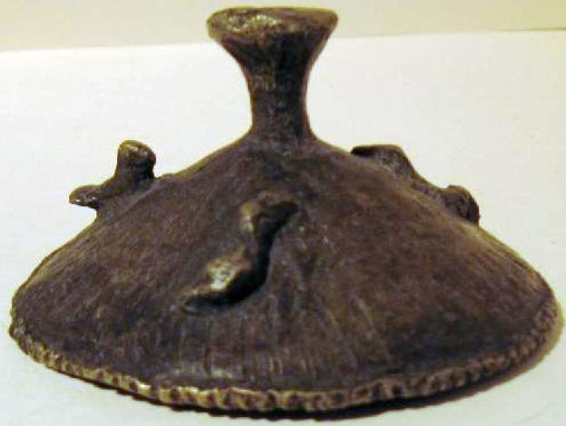

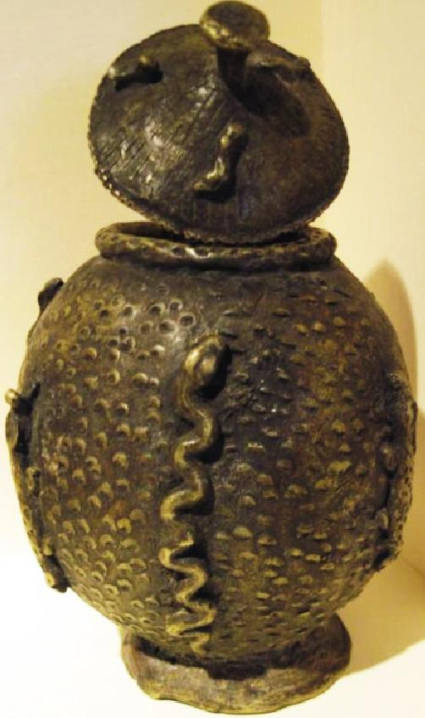

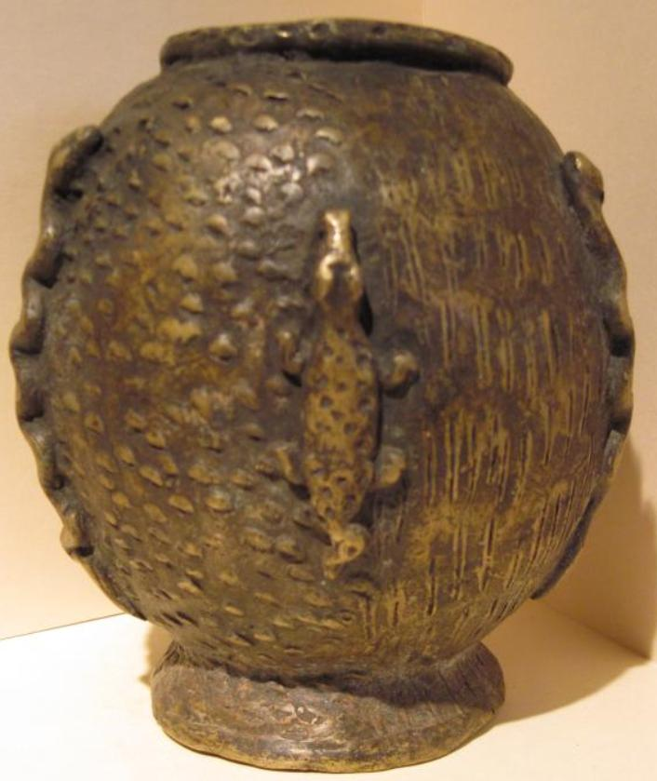

Fig. 1 (left, above) Benin reliquary lid with birds, Fig. 2 (left, below) Benin reliquary jar with crocodile between savannah motifs and streaming water motifs, signifying it is a creature between two media: land and water. Fig. 3 (right) Benin reliquary jar with python between savannah motifs, signifying it is a land animal.

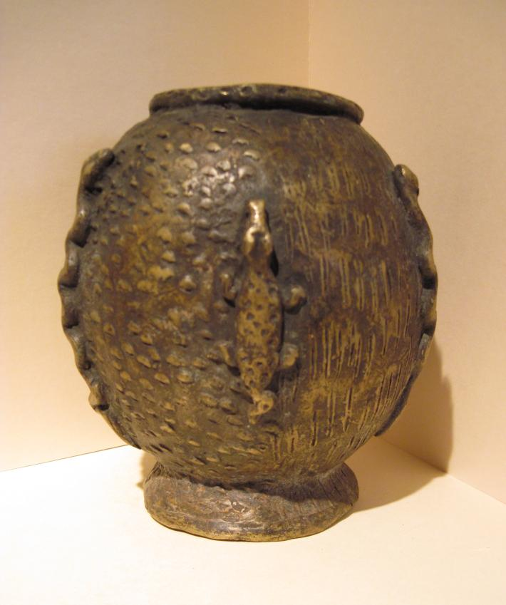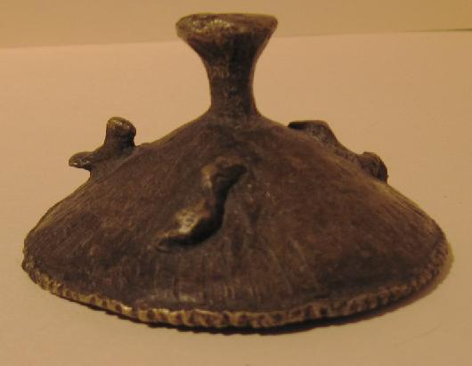

Figs 1-5. Benin-Bronze-Reliquary Jar-Snakes and Crocodiles-19th c

Formal Label: Benin-Bronze-Reliquary Jar-Snakes and Crocodiles-19th c

Accession Number:

LC Classification: N7397

Date or Time Horizon: 19th century

Geographical Area: Benin, Nigeria

Cultural Affiliation: Benin

Medium: Bronze

Dimensions: Weight:

Provenance: European Collection

**Condition: Fine**

**Discussion:**

This reliquary jar with African rock pythons (*Python sebae*) and crocodiles (*Crocodilus niloticus)* was meant to hold *exotic* royal appurtenances such as *Oba's* coral beads (*ivie)* from trade with the Portuguese (which began in 1470) from the Mediterranean or cowrie shells from the Indian Ocean also from trade with the Portuguese. In contrast, the motifs of *indigenous* pythons and crocodiles were traditional symbols meant to protect the jar's contents and the avian motifs on its lid were meant as spirit helpers to the person wearing the contents.

Through the shedding of their skin, African rock pythons symbolize renewal and rebirth and in this sense are considered as symbols of immortality. African Rock pythons are also formidable, attaining a length of ca. 6 m. (20 ft.) and a weight of 200 pounds. In Benin pythons are regarded as messengers of *Olokun*, the Yoruba female deity of the sea, and python plaques decorated the palace of the *oba* (hereditary chief). The placement of the python on this reliquary jar may have signified that the contents of it belonged to the sea realm of Olokun, i.e., coral beads or shells.

African crocodiles were also depicted on plaques that decorated the palace of the *oba* (Forman, Forman and Dark 1960: 55, plate 86). According to Yoruba tradition, crocodiles, having the ability to both swim in water and walk on land provided a metaphor of the *oba* (hereditary ruler) who both lives in the ordinary world and lives in the realm of spirits and gods (Lynch 2004:29-30). Therefore, the placement of the crocodile on this élite reliquary jar may have signified its kingly ownership.

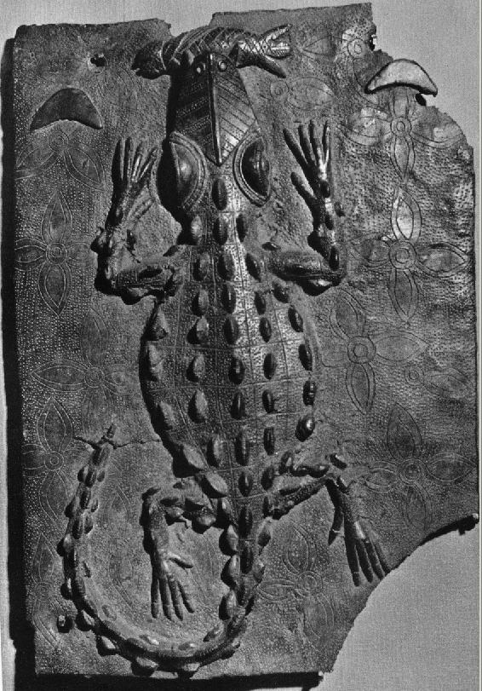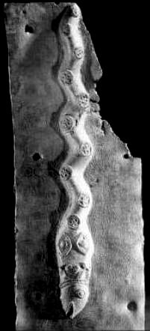

Fig. 4 (left) Benin bronze plaque with python ingesting a fish (Werner Forman, Art Resource, NY from Lynch 2004: 93).

Fig. 5 (right) Benin bronze plaque 20 in. h., 13.5 in. wide, British Museum cat. no. 98.1-15.172 (from Forman, Forman and Dark 1960: 55, plate 86). The two half moons may signify the female power of Olokun (with the menstrual period roughly corresponding to the phases of the moon) over the crocodile. The crocodile probably was considered by the Yoruba of Benin as having an apotropaic or protective power since its skin was used for warriors' helmets (Forman, Forman and Dark 1960: 42, plate 42; Read and Dalton 1899, pl. xx/4; Luschan 1919, text vol. p. 258, fig. a, b).

**References:**

Forman, W. Forman, B. and Dark, P. 1960. *Benin art*. London: Hamlyn.

Luschan, F. von. 1919. *Die Altertümer von Beni*n. Berlin and Leipzig: De Gruyter.

Lynch, Patricia Ann. 2004. *African mythology A to Z*. New York : Facts on File.

Read, Charles H. and Dalton, O. M. 1899. *Antiquities from the city of Benin and from other parts of west Africa in the British Museum*. London: British Museum.